8086 Hardware Specifications
Dept. of Computer Science and Engineering

Lecture References:
- Book:
  - Microprocessors and Interfacing: Programming and Hardware,
Author: Douglas V. Hall

  - The 8086/8088 Family: Design, Programming, And Interfacing,
Author: John Uffenbeck.

- is a 40-pin DIPs; Dual in-line package
- DIP refers to a rectangular housing with two parallel rows of electrical connection pins.
- DIPs have a notch on one end to show its correct orientation.
- The pins are then numbered as shown in the figure below.
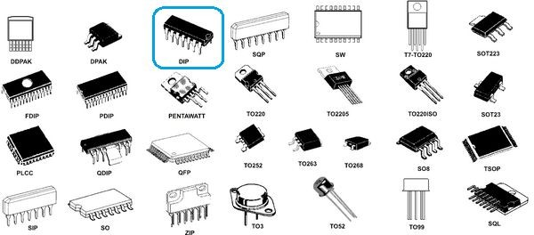
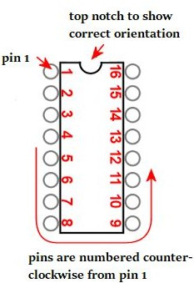

8086 Pin Diagram

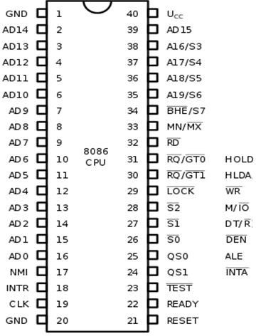

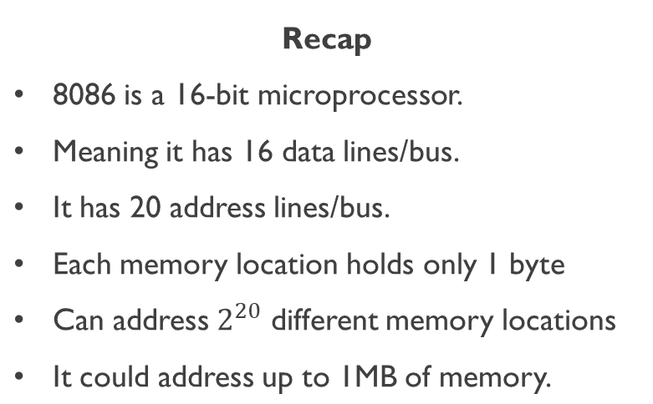
min mode max mode

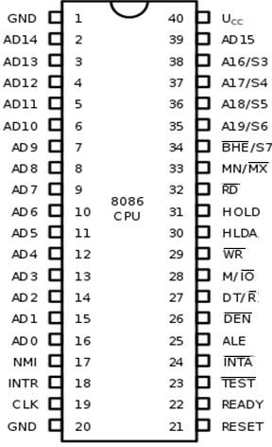
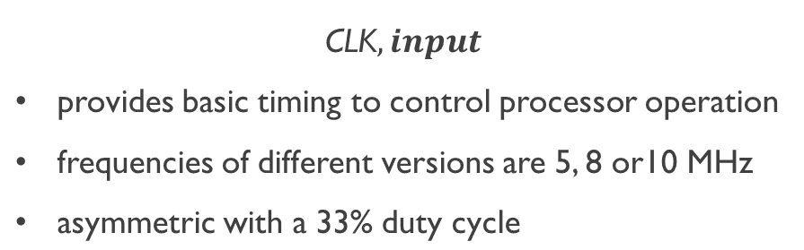

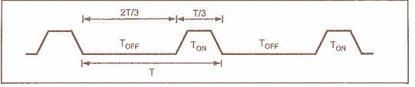
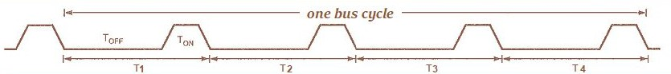

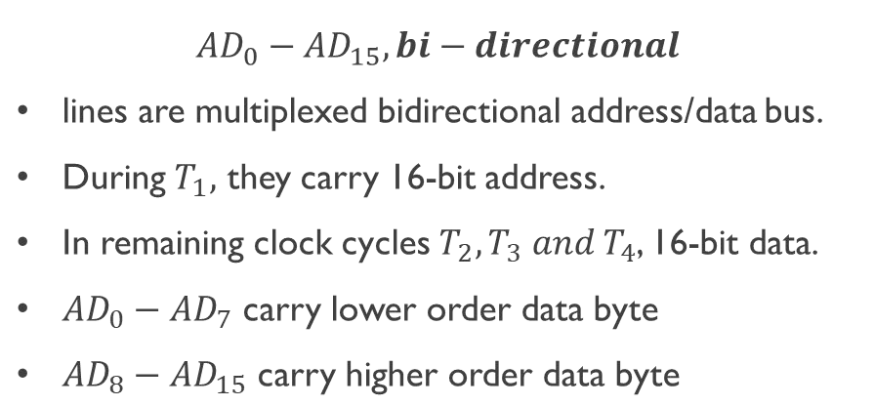
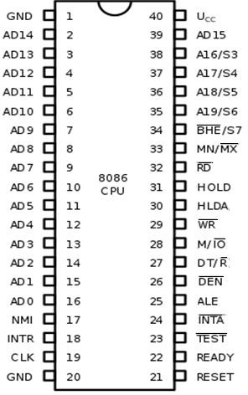

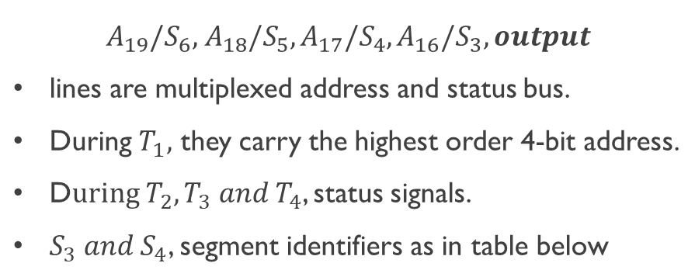

S4 | S3 | Function
0 | 0 | Extra segment access
0 | 1 | Stack segment access
1 | 0 | Code segment access
1 | 1 | Data segment access

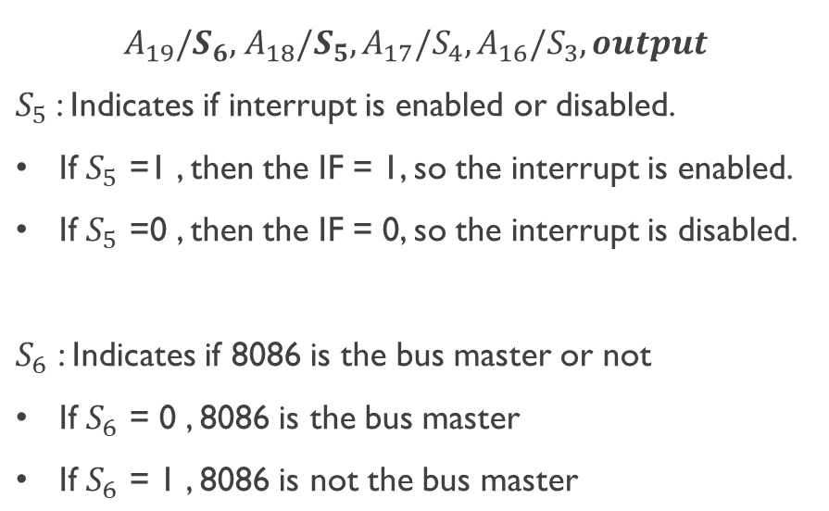


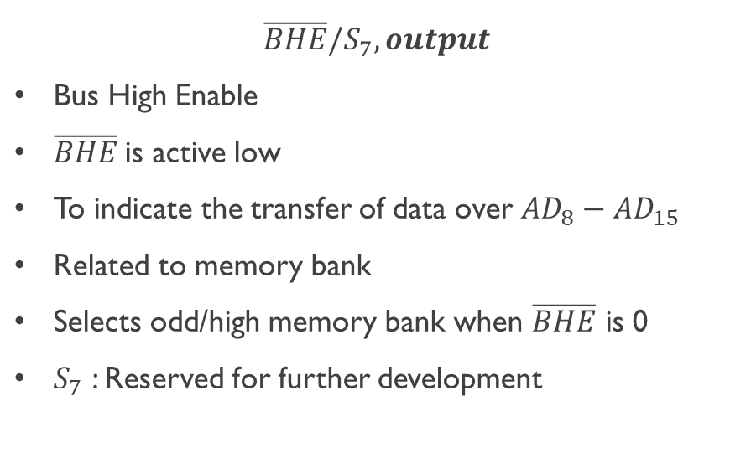



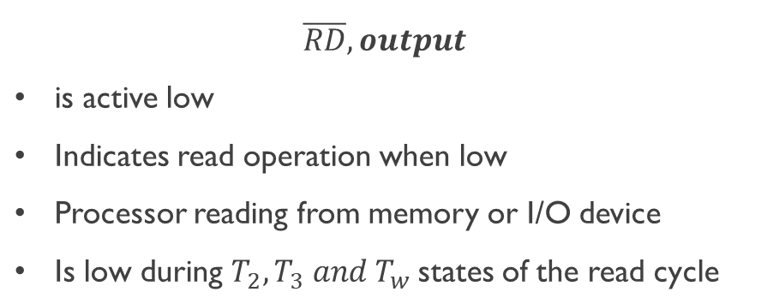


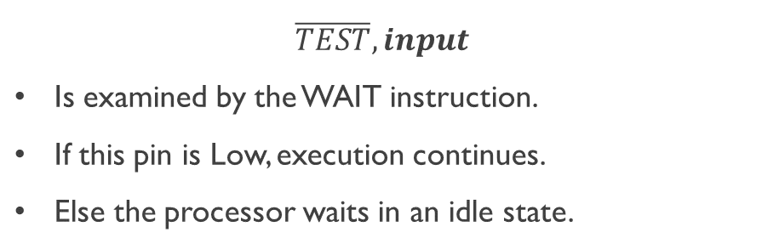


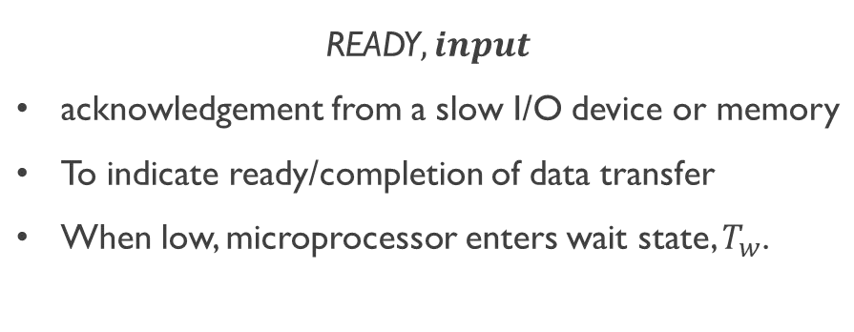


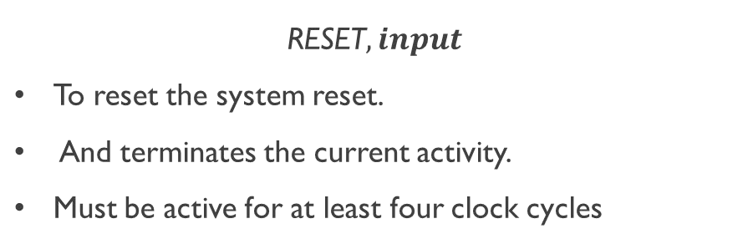


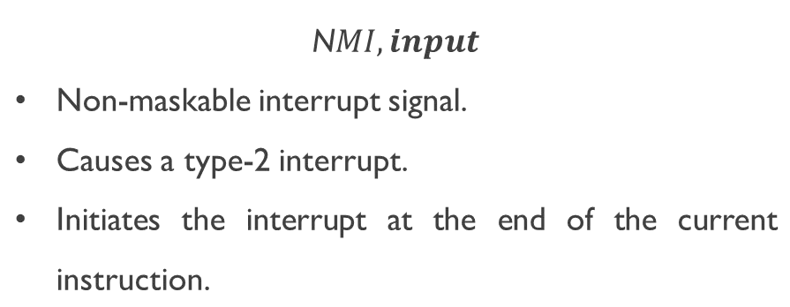
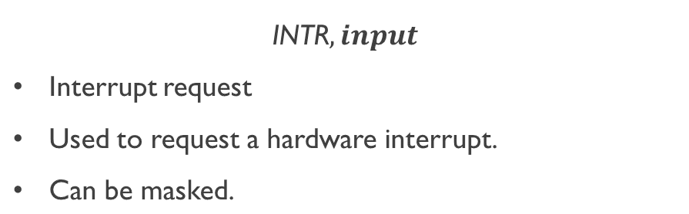




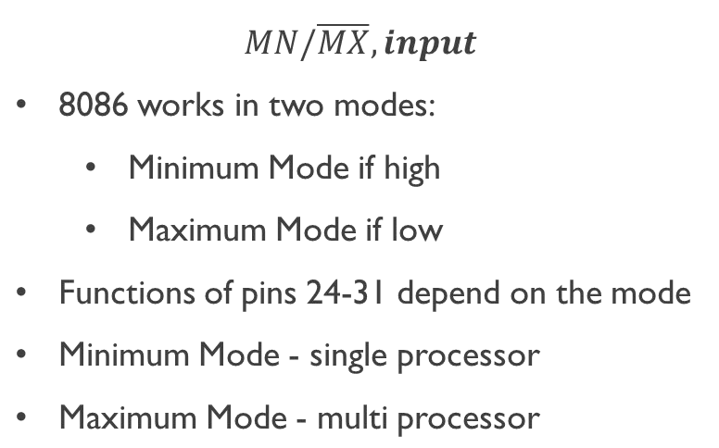
n mode

mi max mode

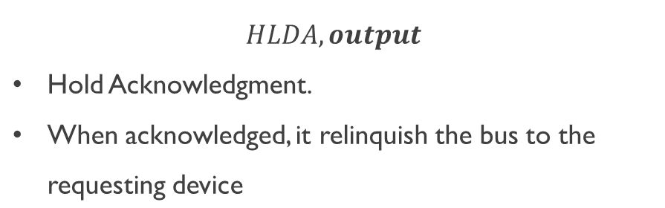




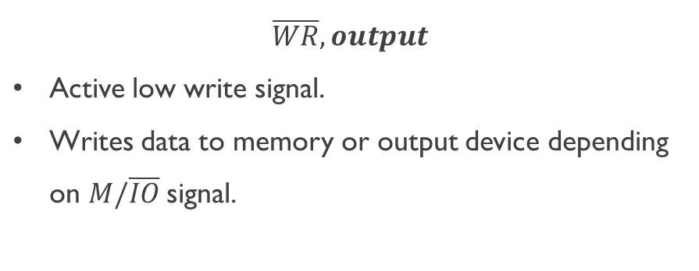
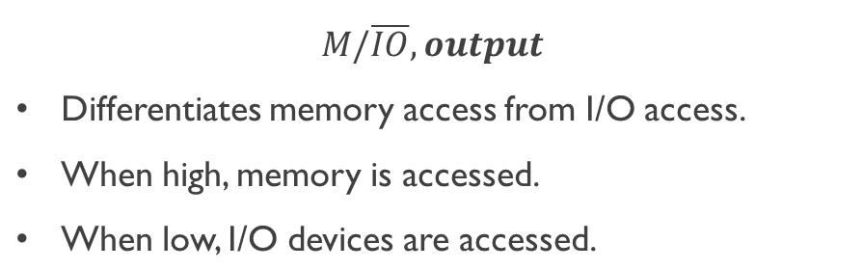

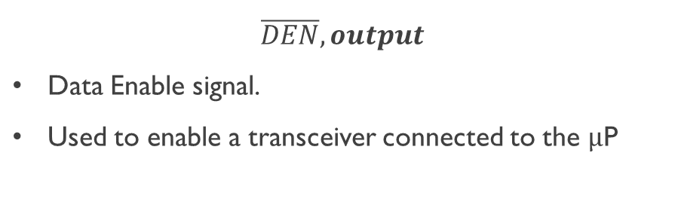
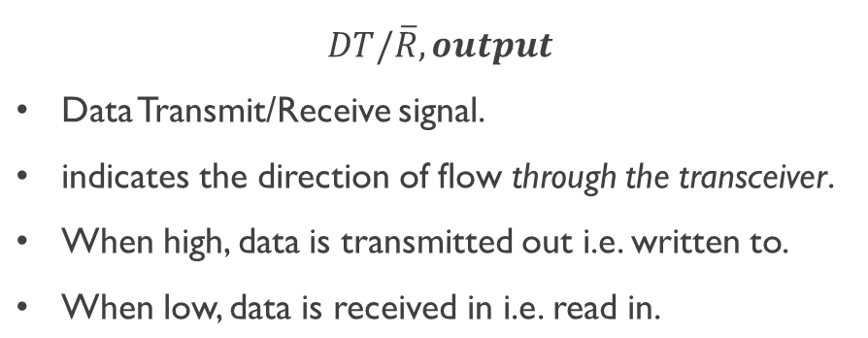


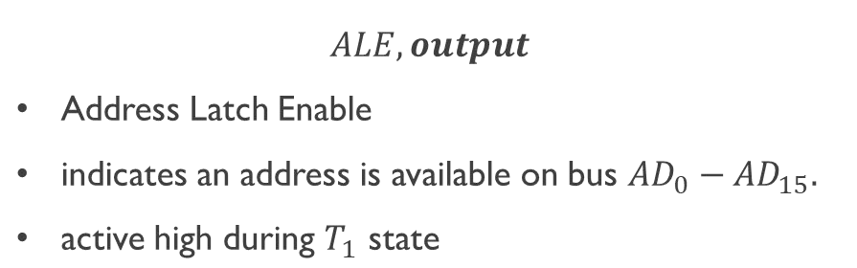


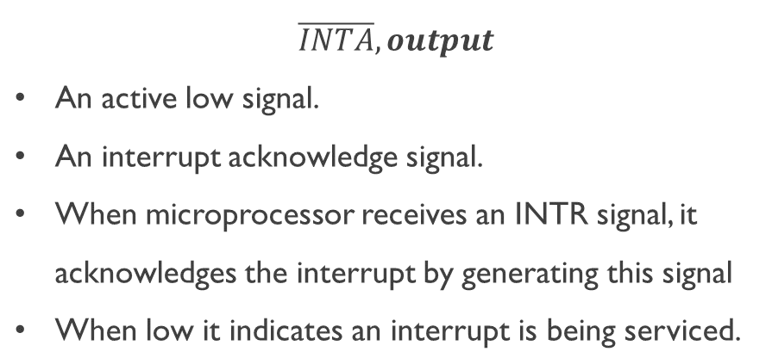


8086 Maximum Mode Pins
Dept. of Computer Science and Engineering

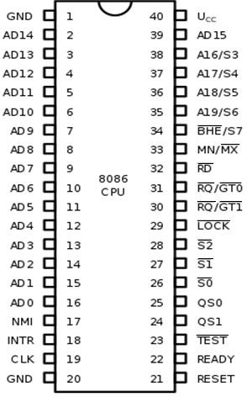
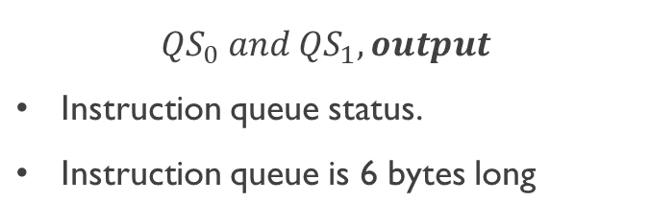

Function
0 | 0 | No Operation. During the last clock cycle, nothing was  taken from the queue.
0 | 1 | First Byte. The byte taken from the queue was the first byte of the instruction.
1 | 0 | Queue Empty. The queue has been reinitialized as a result  of the execution of a transfer instruction.
1 | 1 | Fetch subsequent byteSubsequent Byte. The byte taken from the queue was a subsequent byte of the instruction.

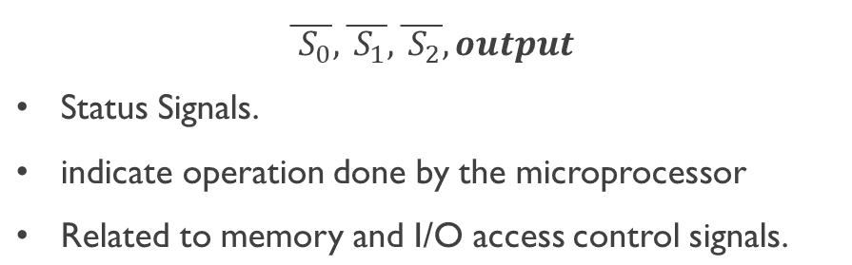


Function
0 | 0 | 0 | Interrupt acknowledgement
0 | 0 | 1 | Read data from I/O port
0 | 1 | 0 | Write data from I/O port
0 | 1 | 1 | Halt
1 | 0 | 0 | Opcode fetch
1 | 0 | 1 | Memory read
1 | 1 | 0 | Memory write
1 | 1 | 1 | Passive state

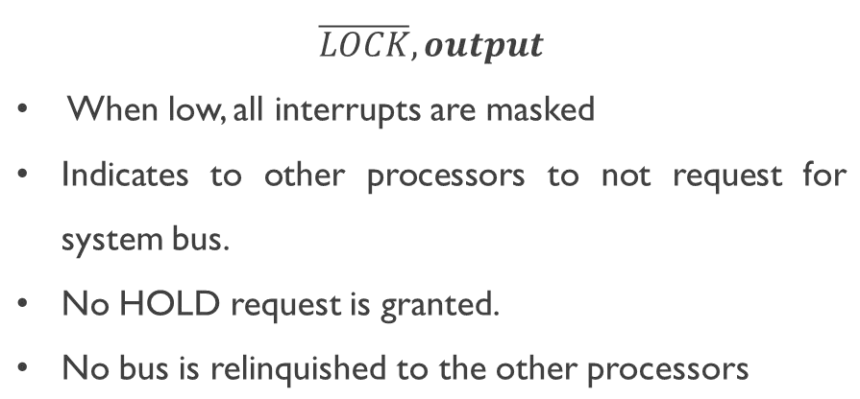


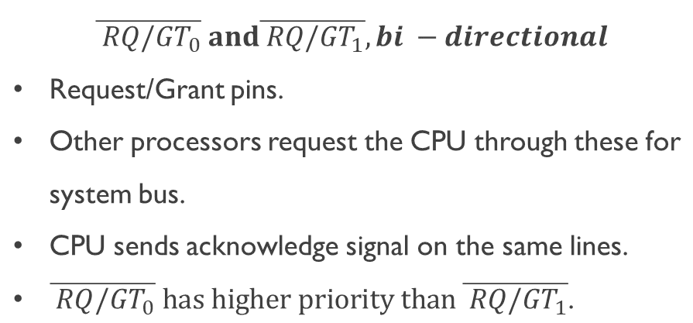


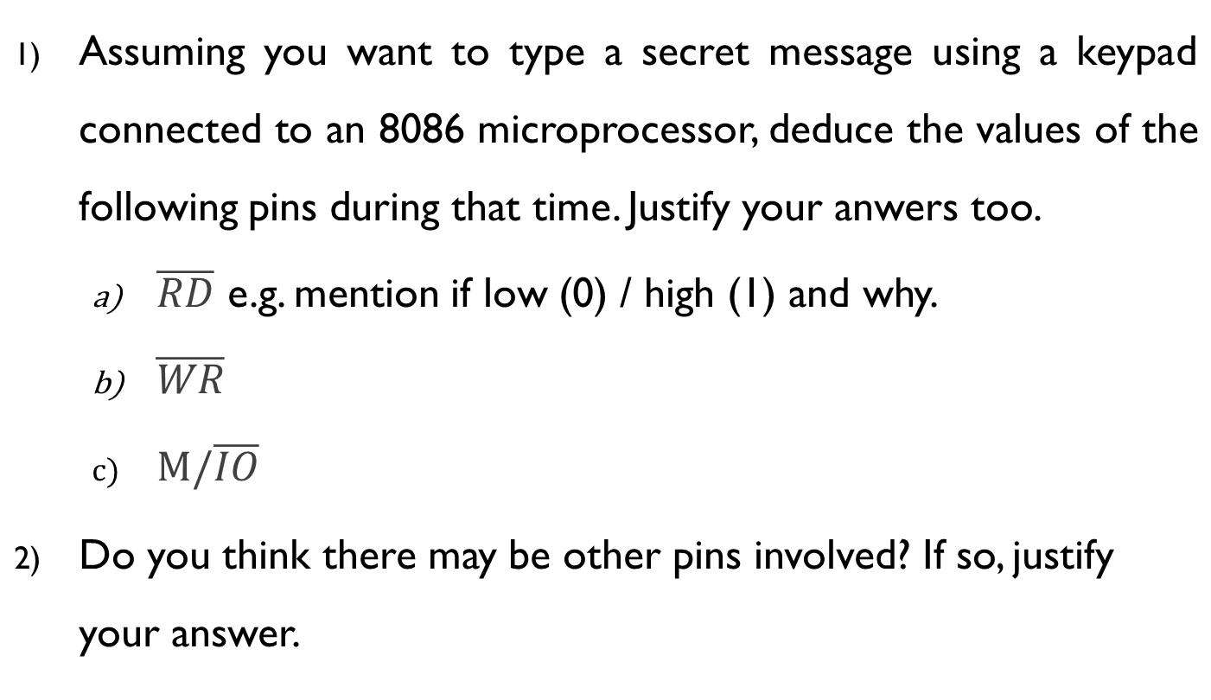
QUIZ

